Tips for a good night’s sleep

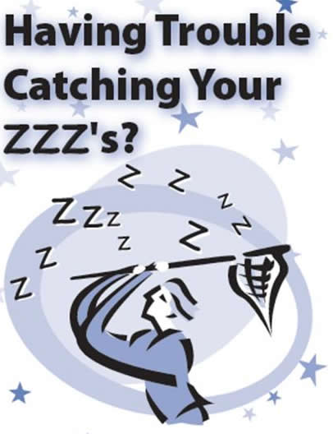

Sleep is an important part of your daily cycle. You need sleep as it:

- Gives your body chance to repair
- Gives time for your internal organs to be cleansed
- Enables you to process the day’s events (in the form of dreams)
- Reduces stress, anxiety levels and mood swings.

There are two main cycles of sleep that you need to be aware of: REM sleep, otherwise known as dream sleep, and slow wave restorative sleep. Any worries or stresses that don’t get resolved during the day are processed during REM dream sleep. REM stands for Rapid Eye Movement. REM sleep should amount for up to 2 hours of your sleep each night, or approximately 25%. In times of stress there is more processing for the mind to do so REM sleep is extended.

Slow wave (restorative) sleep should make up 75% of your nights sleep. This is where the tissues of your body are repaired and where your brain has the chance to relax and recuperate. Not enough slow wave sleep time will leave you feeling exhausted, needing even more sleep. It is temping to take afternoon naps or go to bed earlier but if you aren’t dealing with the stress and worries of the day you won’t decrease the amount of time spent in REM sleep and so it won’t make any real difference. But there is a solution.

The key is to lessen the amount of stress on your physical, emotional and mental system especially just before bed in order to decrease the amount of REM dream sleep. Below are some ways of helping.

How much sleep you need each night varies from person to person but on average it is between 7-8 hours per night. A regular sleeping pattern will help you to find out what suits you best. The right amount of sleep should leave you feeling refreshed and energised.

Sleep stoppers

The main sleep stoppers are caffeine, alcohol and sugar. These need to be regulated during the day and restricted during the hours before bedtime. The body needs a sufficient amount of 'fuel' to get through the night, so a balance needs to be found that will help you make it through the night without hunger.

Caffeine
Caffeine is a well known stimulant. It is also found in other foods and drinks such as tea, chocolate and soft drinks e.g. coke.

Caffeine raises the levels of the hormones adrenalin and cortisol which helps keep you active and alert during the day. Too much coffee can make you feel shaky and anxious and interfere with sleep. Studies have shown that coffee drinkers can take twice as long to fall asleep and sleep less, compared to those drinking decaf.

Alcohol
Alcohol is a relaxant but unfortunately is best avoided by the insomniac. The initial effect is to switch off adrenalin which helps you to feel relaxed. After a few hours the body starts to adjust and try to regulate the affects. This interferes with the different stages of sleep making you feel tired and irritable in the morning. Alcohol affects the quality of sleep and causes dehydration.

Sugar
Sugar affects the levels of the adrenal hormones causing them to rise if blood sugar levels are too low. Raised night time levels of cortisol may also affect tissue repair and speed up the aging process.

Fast foods
Fast foods and takeaways are often high in fat and contain artificial colours and flavourings that are stimulating and hard to digest. Foods that are labelled as 'low fat' often contain additional sugar which affects sleep.

In general it is best to try and prepare meals from scratch - that way you will know exactly what they contain.

Anger and anxiety
Going to bed angry, it is easy to stay in this 'revved up’ state making it impossible to relax and fall asleep! It is the same with high levels of worry and anxiety – the more you think about your concerns the bigger and more out of control they can feel. If you tend to worry try writing out your worries before you go to sleep. Keep a pen and paper next to your bed so if any pop up during the night you can jot them down and deal with them in the morning.

Beating tiredness

1. Things you can start doing today
- Go to bed and get up in the morning at the same time every day, no matter how you feel.

- Make sure your bedroom is comfortable: not too hot, not too cold, and not too noisy. Is your bedroom a relaxing place to be?

- Don't eat or drink too late at night. Try to have your evening meal early rather than later. Saying this, having a milky drink before bed can help.

- Try to gradually reduce the time you spend 'napping' during the day.

- If you can't sleep, don't lie there worrying about it: get up, leave the bedroom and do something you find relaxing. When you feel tired enough, go back to bed.

- Pick a way to relax before going to bed - such as reading, listening to music or using a relaxation technique. TV keeps the mind active and it prevents you noticing signs of tiredness.

- Have a hot bath before bed.

- If something is troubling you, and there is nothing you can do about it there and then, try writing it down. Tell yourself you will deal with it in the morning, and then go to bed.

2. Take some exercise
Many people feel too exhausted to start any exercise. However, in the long run, regular exercise will make you feel less tired and more energetic. Exercise releases ‘feel good’ hormones as well as preparing the body for a good nights sleep.

3. Relaxation techniques
When we are stressed the nervous system responds to this by activating the ‘flight’ or ‘fight’ reflex. This arouses the body ready for action. Little does the nervous system know that usually the danger isn’t life threatening: maybe the stress is related to an overdue essay, money worries and friendship concerns. The nervous system has a way of bringing the body back into a state of calm yet the more we worry, the less this happens. Too much stress increases REM activity which means exhaustion in the morning.

If you wake feeling just as tired as when you went to bed what you need to focus on is trying to relax more in the day. Try this simple breathing exercise:

- Focus on the tip of the nose with the air entering and leaving breathing in and out of the nose. Try and relax your body as much as possible.
- As you breathe in, count to 4 (in your head)
- As you breathe out, count to 6.
- Pause at the end of the out breath.

The out-breath is known to regulate the body – to bring it back into a state of calm so by making the out breath nice and long you will be helping to decrease worry and tension and in doing so you will spend less time in REM dream sleep.

College Counselling Service

The college counselling service can help you to talk through these issues and look at how we can help.
Bedfordshire
01234 291911
counselling@bedford.ac.uk
Northamptonshire
01536 513273
Counsellingtresham@bedford.ac.uk
You also drop in to Student Services or speak to your Personal Achievement Tutor

