Stress busting
How to identify and deal with stress

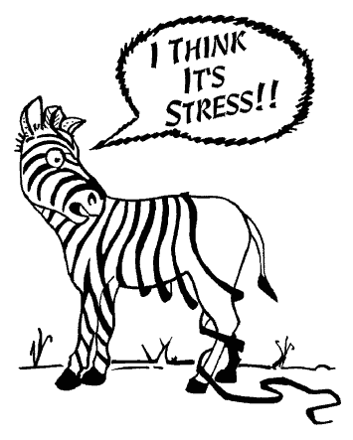

Stress is something that most of us have in common. In fact, it is a normal part of life and a little bit of stress is healthy, for example, it makes us get up in the morning and get to college on time; it can help motivate us to finish assignments and study for exams. However, if we are not careful the balance can tip and we can find that we are not coping.

It can be useful to learn the symptoms of stress so that you can identify when your stress-levels are building up and likely to create overwhelm and exhaustion.

Common symptoms of stress | Some causes of stress
- Lack in concentration  - Over worrying  - Loss of appetite  - Lack of energy  - Feeling tired all of the time  - Backache and shoulder tension  - Restlessness  - Feeling irritable and/or agitated  - Sleeping too much or too little  - Catching more colds than usual  - Not coping/overwhelm | - Starting something new e.g. college or a new job  - Being too busy  - Family problems or a change within the family  - Moving home  - The death of someone close  - Financial worries  - Setting unrealistic goals  - Perfectionism  - Adapting to a new environment  - Relationship break-ups

The causes of stress can sometimes come out of the blue or build up over a period of time so you don’t quite notice the tension building until it is too late. It is important to notice the symptoms and to seek help before things get out of hand. Simply talk to your personal tutor or pop along to a counselling drop-in session. You might not even know the cause of your stress but you feel moody, tired and irritable; that’s fine. The counselling service can help you to identify what is going on for you and help you to understand your feelings.

There are many ways in which you can manage your stress levels. The key question to ask your self is: can I change what is happening? If you can’t change the situation, then look at how you can respond differently. Here are some helpful hints:-

- It can be helpful to ask a friend or family member to sit down with you to look at where your life has become imbalanced. A fresh pair of eyes can often see an easy way around the problem. If you don’t feel like you have anyone close to share things with, or that your worries feel too big, you can always speak to your Student Personal Advisor, Personal Tutor or make an appointment to see the college counsellor.

- Write down everything that is on your mind. Make two lists – things you have control over e.g. studying towards an exam and things beyond your control e.g. parents splitting up or college course coming to an end. Just by seeing what is on the lists can help to gain perspective. Can you write action points for each item on list one – the things you have control over?

- Try this 10 second meditation. Just pause. Bring your attention to the air entering and leaving your nose. Be aware of the temperature of the air that goes in compared to the air that comes out. This has an instant calming effect on the body helping you to clear and focus your mind. Do this as often as you can.

- Eat healthily. When we are stressed our immunity drops making us more susceptible to coughs and colds. When we are stressed, we often forget to eat so make an effort to include plenty of fruit, vegetable and water in your diet.

- Exercise of any kind plays a key role in decreasing stress levels. Exercising on a regular basis can help prevent the build up of stress.

College counselling service

Bedfordshire
01234 291911
counselling@bedford.ac.uk
Northamptonshire
01536 513273
Counsellingtresham@bedford.ac.uk
You also drop in to Student Services or speak to your Personal Achievement Tutor

