Understanding and managing your Anger

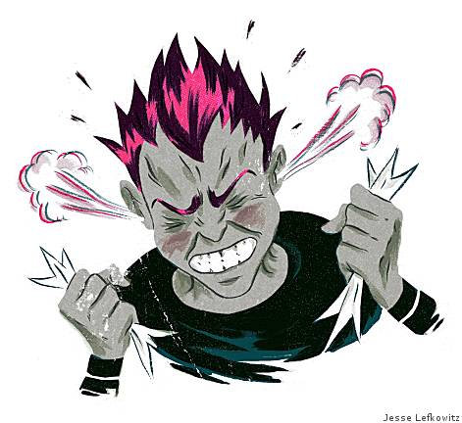

Anger is a common response to something that we don’t like. It is a perfectly normal emotion that alerts us to: when we are doing something that we don’t want to do; or that someone has done something to us that we don’t like i.e. been disrespectful. It is not the anger that is the problem but rather how we express ourselves when feeling angry.

So, what is anger?
Anger is a mixture of both emotional and physical changes. When a situation feels threatening, a big surge of energy goes through your body as chemicals, such as adrenaline, are released, getting the body ready for some kind of action – usually associated with flight or fight. There are two main ways in which we deal with these physical and emotional changes: one is to implode and the other to explode. Most of us are dominant in one of these ways of reacting yet are likely to carry a bit of both.

Imploders turn their anger inwards as they don’t share their feelings with others, but instead bottle them up. When feeling angry they withdraw, sulk, become hostile and manipulative. Imploders may behave in passive aggressive ways, so they might sulk, withdraw, gossip, pull faces and resort to cyber bullying. Imploders generally carry guilt and have feelings of low self-worth and self-esteem not feeling worthy to air their views. Suppressed anger will eventually explode into some area of the person’s life manifesting in conditions such as: eating disorders, self-harming, high anxiety, unhealthy relationships, and addictions such as smoking, drinking and/or taking drugs. They may even lash out unexpectedly in violence.
Imploders may carry their unexpressed anger in their body as a headache, or muscle tension or stomach ache. Infections are often associated with anger.

Exploders, on the other hand, regularly overreact taking their anger out on anyone in their path. Exploders are aggressive displaying this behaviour
by: shouting, hitting, pushing and name calling. Exploders often express their anger where it isn’t justified e.g. we may find ourselves overreacting with a member of our family when it is a friend we need to be expressing our anger to. Out of control anger may also be directed towards an object – hitting a wall for example and in extreme cases it can turn into self-harm (for more info. on this read the leaflet on self-harm).
As a society we seem to value those who are able to suppress their anger (implode) rather than explode with it, yet both are just as harmful in the long run. Anger doesn’t just affect the people it is being directed to but can create a loss of confidence and self-esteem in the person feeling angry, often accompanied by feelings of shame.

Anger triggers
What is it that makes you angry? Make a list of all of the things that trigger your anger. Next to each point on the list write out the different words associated with how you felt. These words may look something like: frustrated, angry, intolerant, agitated, irritated, annoyed, rage, betrayed, let down, disrespected, scared. Now take each item on the list and consider what it is you make the situation mean, for example, your friend talking about you behind your back may trigger extreme anger. This is because you feel disrespected and betrayed. When you can find out what is behind the strong feelings you will be more able to talk about the actual problem and find a solution to it.

Situation Feelings Meaning attached Solution
It is the meaning attached that often creates an outburst of anger!

Situation | Feelings | Meaning attached | Solution
Having an argument with a friend | Annoyed, agitated | They never listen to me | Formulate what it is that you want to say and ask the person if you can talk about it calmly
Losing your homework | Anger, frustration, intolerance | I always lose things. Now I’ll never get my work finished | Talk to your tutor – explore your options.
Try an example for yourself:

Look at the box in red – the meaning attached to the situation. This box usually contains words like: never, always and should. This is known as ‘all or nothing thinking’ and is rarely based on fact. When caught up in this way of thinking solutions are always just out of reach. Try to catch this thinking when you next feel angry – what are you making the situation mean? It is the meaning in the red box that can make you feel out of control but in actual fact this is the only bit you can fully control AND change!

Managing your anger
The flip side to anger is that it can feel good as it is being released, therefore, it can be helpful to find other, more positive, ways of releasing this powerful energy.
- Exercise like running or a non-contact competitive sport like squash or netball
- Creative pursuit like drumming or singing
- Going for a brisk walk outside
- Hitting a pillow
- Meditation and relaxation – try closing your eyes and placing your hand on your tummy just below your belly button. As you inhale push your tummy out slightly and as you exhale let it go down. Do this for 10 breaths. Practicing this a little every day will help you when you are in a situation that’d trigger your anger.

The college counselling service
Bedfordshire
01234 291911
counselling@bedford.ac.uk
Northamptonshire
01536 513273
Counsellingtresham@bedford.ac.uk
You also drop in to Student Services or speak to your Personal Achievement Tutor

