Understanding your eating disorder

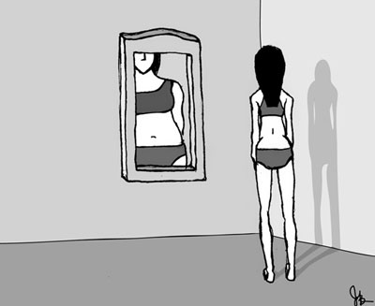

Eating disorders are serious conditions with young people between the ages of 14-25 being most at risk. Eating disorders affect the way you feel about yourself, can isolate you from friends and stop you from achieving in life. It is said that at least 1.1 million people in the UK are affected by an eating disorder, so it is important to realise that you are not alone if your eating habits are giving you cause for concern.
So how to you know if you have an eating disorder? The biggest clue is your change in attitude towards food. Do you feel like you no longer look forward to your meals or enjoy eating? If you find that you are controlling your food intake, constantly thinking about food and feel bad about yourself when you do eat then there is a chance that you have an eating disorder. Below, the different types of eating disorders are outlined, along with signs and symptoms. If you recognise the signs and symptoms or are concerned about your eating habits in any way then do get in touch with one of the college counsellors who will be able to help you. The following link provides you with more information on how to identify which category you fall into:
http://www.eating-disorders.org.uk/do-i-have-eating-disorder.html

Types of eating disorders
Overeating, under-eating, purging, over exercising or a combination of these behaviours are frequent occurrences in everyday life for someone with an eating disorder, so much so that their health can suffer severely from poor nutrition and their normal daily routine becomes difficult.
The main types of eating disorders include:
- Anorexia Nervosa - There are two types of anorexia: the restricting type and the binge eating / purging type combined with a distorted body image.
- Bulimia Nervosa - is characterised by regular binging and purging of food (bulimics will often get rid of food by vomiting, using laxatives or starvation).
- Binge Eating Disorder A person with this condition frequently consumes large amounts of food at one sitting while feeling a loss of control over what they are doing.
It is possible for these conditions to co-exist alongside one another.

Signs
Here are some signs and symptoms to look out for that may suggest you have, or are on the verge of developing, an eating disorder.
- Obsession with body weight / being overweight
- Only eating certain types of food
- Calorie counting everything you eat
- Picking at food
- Use of the bathroom immediately after eating to vomit
- Feeling terrified of gaining weight
- Making excuses not to eat at meal times
- Rapid fluctuations in weight (weight loss or weight gain)
- Mood swings
- Excessive use of exercise

Causes of Eating Disorders
Causes of eating disorders include a number of complex, interwoven, social, psychological and biological factors.
Eating disorders often occur as a result of deeper emotional and psychological problems, whereby controlling food intake through overeating or under-eating is used as a coping mechanism for feelings such as stress, anxiety, depression, sadness, anger or other difficult emotions.
Body image distortion/negative body image and low self-esteem are strongly implicated as other causes of eating disorders.
Other causes to consider are physiological in nature. It is possible that some people have a genetic predisposition for developing eating disorders, or that eating disorders are caused by chemical imbalances in the brain. It has also been suggested that dieting is a slippery slope to an eating disorder.

It can be very confusing for the person who finds them selves thinking about and controlling their food for most hours of the day. The feelings associated can be vey frightening and it can seem that you will never be okay again.
It is common for the person suffering from unhealthy eating patterns to think that they have no-one to turn to, that others won’t understand or be able to help. It is important to realise that this isn’t the case. In most cases, close friends and family members are already concerned and are looking for ways to help. Talking can be the first step towards leading a normal and healthy life again.
Resources
www.eating-disorders.org.uk
www.b-eat.co.uk
http://www.disordered-eating.co.uk/signs-of-eating-disorders/signs-of-eating-disorders.html signs

To contact the Counselling Service
Bedfordshire
01234 291911
counselling@bedford.ac.uk
Northamptonshire
01536 513273
Counsellingtresham@bedford.ac.uk
You also drop in to Student Services or speak to your Personal Achievement Tutor

