When relationships go wrong!

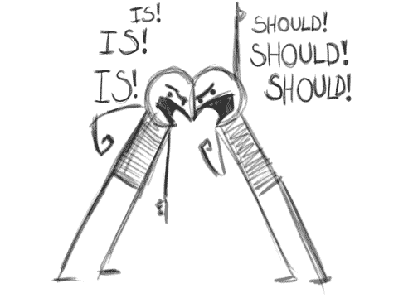

It can feel very stressful when relationships break down or we have a bust up with a friend. We need people in life, for support, fun, talking and sharing because we are social beings. It is positive contact with others that keeps us strong and resilient. Being resilient means you are able to bounce back after a stressful situation. It is by asking for help, sharing our problems and bouncing ideas around that enable us to deal with problems and move on. This then enables us to have fun with our friends.
Falling out with friends or partners can feel very confusing especially if you are not quite sure what you did to upset the other person. You might remember a time when things felt great between you and you just can’t figure out what went wrong.

By remembering the good times and what you value about that person can be very helpful in order to keep perspective. When relationships break down it is rarely the fault of just one person. If we’ve been focusing on the negative aspects of a friend, we may become over critical and blaming. Sometimes we need to take a step back and look at our behaviour in the relationship. You can ask yourself: have I been honest and told them how I feel? Am I able to see the problems from their side too?

Backgrounds: no two people share the same backgrounds. Even siblings will have different experiences of their upbringing, for example, older siblings would have had time being the only child, never having to share their parents. The 2nd child will only know having to share their parents. Differing backgrounds include ethnicity, culture, the kind of family structure (e.g. single parent, or lots of siblings) and experiences at school and with past friendships. Any past traumatic experiences are likely to surface in current relationships and can be very confusing for all involved. Think about your background; write a list of what makes you different from others.
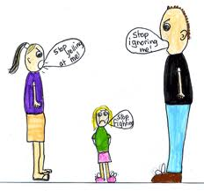

Values: we get our values from parents and the wider community. Think about what is important to you; write a list under the following headings: family, friends, college, career, money, myself. A value may look like: it is important to be able to lend each other money but it must be paid back as soon as we get paid.
Belief systems: these are statements that we hold in our mind (whether we know it or not) about ourselves and the world around us. These are formed by our upbringing. Examples are: “it is okay to make mistakes; all things can be fixed,” “the world is unsafe” “you can’t trust anyone” “people always let you down” “if I work hard, I can achieve anything.” You can see beliefs are a mixture of positive and negative. Looking at the beliefs above, think how they might affect relationships? What would happen if a friend turned up late? Imagine the same situation for two different people. One thinks “it’s okay to make mistakes” the other “people always let you down.” What behaviour would each demonstrate (words, actions)
Desires: these are the things we want from life: from ourselves, others and life in general. It is perfectly natural to want material possessions, to have ambitions and to want to better ourselves, however, if our desires are very different from the person whom we are relating to then things can get tricky. For example, if a person loves gadgets and spends all their time and money on mobile phones, ipads and games and you like to go for meals, to the cinema or for walks then this could cause a problem if the two of you are unable to compromise.

This is when we can start to expect the other to change and may say or think, “if you really love me then you’d do what I like doing.” Another example is, if one of you is very career minded and the other just wants to travel and bum around. So for friendships and relationships to be long lasting you need to feel like you are going in a similar direction and value similar things. Saying this, it is also very healthy to have different hobbies and friends – this is necessary to stay strong as an individual.

So a good healthy relationship is a two-way thing. It takes a lot of understanding and for it to succeed requires us to think beyond ourselves: our background, values, beliefs and desires. We need to take responsibility for our actions and expectations and we need to know what we want from a friendship.

Here are some pointers:

Healthy friendships & relationships include: | Unhealthy friendships & relationships include:
Caring  Honesty  Trust  Fun  Openness  Quiet times  Exciting times  Communication  Respect  Sharing  supportive  Commitment  Understanding | Jealousy  Aggressive behaviour:  Shouting  Pushing  Hitting  Violence  Name calling  Mean Jokes  Selfishness  intimidation  manipulation  Wanting constant attention  Lying

What to do if you realise you are in an unhealthy relationship:
- Ask yourself how much it is affecting your life? How do you feel about the relationship? Are you afraid? Do you feel unsafe? Does this friend/partner knock your confidence? Try and get some perspective on the relationship asking yourself: is this issue something I can discuss with my friend/partner?

- Do you have another friend or family member that you can talk things through with? This can really help to gain perspective and to see the other persons view.

- Write a list of all the qualities you value in this friend and another list of qualities that you don’t. This can help you get a clearer picture.

- Ask yourself: do you feel valued and trusted by this person? Do you feel comfortable in their company? Can you express yourself and be taken seriously? Do you get your say on arrangements? Do they treat you with respect? If the answers are “No” then seriously consider why you are friends with this person… There are plenty of considerate, supportive and fun people out there who WILL respect you…start making new friends and stay close to your values.

- If you feel afraid, unsafe and have no one to talk then consider making an appointment with one of the college counsellors or talk to your personal tutor. Counselling is confidential and your counsellor will help you to make choices that feel right for you. It is wise not to make any radical decisions (particularly in an abusive situation) before you have gained support of some kind in order not to make things worse.

Contacting the Counselling Service
Bedfordshire
01234 291911
counselling@bedford.ac.uk
Northamptonshire
01536 513273
Counsellingtresham@bedford.ac.uk
You also drop in to Student Services or speak to your Personal Achievement Tutor

