Assertiveness

A self-help guide

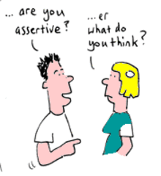

Being assertive is something that doesn’t come naturally to all of us. We learn early on in life how to get what we want and this can be by withdrawing, sulking, getting angry and sometimes even being aggressive. These behaviours may work in the short-term but long-term they can create low self-esteem and a lack in confidence. This can interfere with relationships, achieving well in college and your overall sense of wellbeing.
They arise because we allow our boundaries to be crossed by:-
- Not saying, “no” when you need to
- Being pushed into doing something you don’t want to do
- Being disrespected
- Going along with things for fear of being disliked
- Not understanding something and not questioning it
Ultimately these things lead to a decrease in confidence and self-esteem.
Being assertive means to be able to communicate what it is you want in a clear and concise way. To be able to communicate clearly, we first need to know what it is we want to say. Most of the time, we know that something doesn’t feel right, but we aren’t actually sure what it is that would feel right. When we don’t know what we want, or are too scared to say, “no,” it can feel easier to go along with what everyone else wants. It can feel easier to please those around us, than to stand up for ourselves.
When something happens that we don’t like there are three common ways in which we respond: passively, aggressively or assertively.
Passive behaviours can be:
- Going along with the crowd
- Saying, ‘yes,’ when you don’t really want to do something else
- Sulking
- Withdrawing or withholding information
- Face pulling or name call via the internet
- Talking behind someone’s back, gossiping
Aggressive behaviours can be:
- Yelling and shouting
- Hitting, kicking, pushing, biting
- Shouting over someone when they are trying to talk
Assertive behaviour is:
- Saying, “no” firmly yet politely
- Explaining what you want in a clear and calm voice
- Telling someone that you don’t like what they are doing and if appropriate, offering an alternative way
- Asking for help when you need it
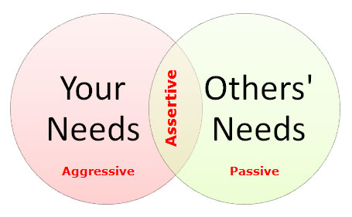
Assertive behaviour is quite different from those outlined above. When someone is communicating assertively you know exactly where you stand. It is easy to mix assertiveness up with being nice. It isn’t about going along with things but rather about being able to say what you want. Becoming assertive can surprise those around you if they are used to you saying ‘yes’ to everything. If your assertiveness is met with attacks or hostility or aggression, then it may be time to consider what kind of friendships you would like to have. Sometimes when we change, our friendships change too.
The college counselling service can help you to talk through these issues and look at how we can help.
To contact the Counselling Service
Bedfordshire
01234 291911
counselling@bedford.ac.uk
Northamptonshire
01536 513273
Counsellingtresham@bedford.ac.uk
You also drop in to Student Services or speak to your Personal Achievement Tutor

