Bereavement and Grief

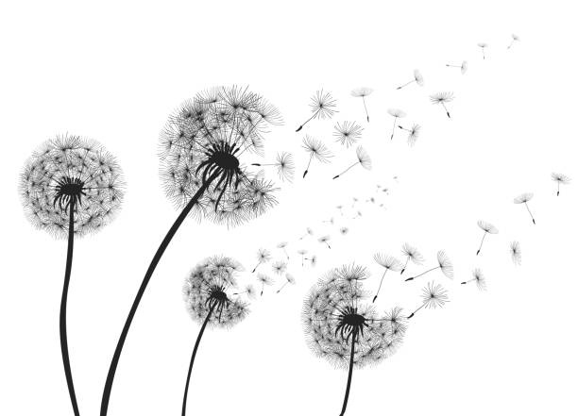

Bereavement and Grief
Serious loss is something that we will all face at some time in our lives and this could be the loss of a friend, work colleague, family member or a much loved pet. Serious loss could also be because of other circumstances such as ending of a relationship, breakdown of parents’ marriage or loss of health. Grief is very personal and can affect people in very different ways. There is no ‘normal’ or ‘usual’ way to cope as everyone will cope with loss in different ways. Whilst everyone’s response to loss is an individual experience, there are still some common experiences that many people will share. There are no right or wrong ways when people experience grief.
It’s important to understand that there is no time limit to grief and you should never feel like you should have overcome your feelings and return to normal day to day life. Grief is a process that you will not start to feel better all at once but eventually it will start to get easier as time goes on. There will be good days and bad days along the way and it is important that you take time to deal with your grief.
Please remember that you are not alone and there are resources, books and helplines that are available to support you as well your own support network of friends and family.
Effects of Grief
Grief can affect your body, mind and the way you think and behave. Some people experience physical and emotional symptoms of friend which may include:
- Disturbed and broken sleep – this may include insomnia, nightmares or dreams of the person you have lost
- Sadness – feeling overwhelmed with your emotions and not finding any joy in anything you do
- Feeling tearful and on edge
- Anxiety – feeling of being anxious or scared, this may include panic attacks. If you have loss someone due to ill-health such as coronavirus or cancer, you may feel anxious about your own health
- Changes in eating habits – you may experience loss of appetite or start to comfort eat
- Loss of motivation – feeling physically exhausted and lacking energy to do anything
- Stress -feeling that there is something heavy sitting on your chest that won’t shift
If you are worried about your own health, it is important that you speak to your GP and explain what you are feeling. They will help identify if you are suffering from an illness or if it is just part of the grief that you are experiencing.
Some people also feel anger at the loss and this could be aimed at themselves or their loved one. This could include thoughts of ‘why did you leave me’, ‘I should have done more’, ‘it’s all my fault’, ‘what have I done to deserve this’ and ‘why them and not me’. This is all normal and part of the grieving process as well as thinking of the future and plans that have now been lost due to your loss.
When you are grieving, you may find that you:
- Avoid places that hold memories
- Withdraw from normal activities and not want to see or talk to people
- Avoid talking about your feelings and emotions to others
- Avoid talking about you loved one
- Become more irritable and finding you are snapping at loved ones
- Feel others are insensitive to your loss as they carry on with their normal day to day life or say things that you feel are not sensitive and diminishes how you are feeling
Grief can put a strain on existing relationships. You can help someone who is going through a loss by talking and listening to them if that is what they want. Be patient and acknowledge that irritability and anger is part of the grieving process. Don’t expect too much and give them time, offering practical help such as support with childcare, shopping, cooking and cleaning. Try not to exclude them or avoid talking to them about their loss. If you feel they are not coping very well, encourage them to seek some help for themselves through talking therapies or their GP.
Take care of yourself
It is important that following a loss and in the days, weeks and months following the bereavement that you do take care of yourself. Your own wellbeing is important to your recovery. This may include:
- Looking after your own health. Try to eat well, rest properly and exercise and just generally take care of yourself. You are more prone to illness such as anxiety and depression after a loss of a loved one. Avoid turning to alcohol or drugs as this is harmful to your body and will affect your emotions and slow down your recovery. If you are concerned about your own health such as loss of appetite, sleep or consistent low mood, then please speak to your GP as they may be able to help.
- Talk to people about how you feel. Support networks are vital, speaking to friends and family has been found to be by the far the most helpful form of support following a bereavement. If you feel you have no one to talk to, there are support groups locally that may also be helpful – these may be linked to your religion or faith or specialist support helplines for bereavement. Sometimes writing how you are feeling and keeping a diary or journal can also help process your feelings
- Ask for help and reach out. If you feel you are not coping, please ask for help or speak to your GP. There are specialist bereavement support available if you feel you wish to speak to someone who is not your GP, family or friend. Don’t keep your emotions bottled up as talking can help process your emotions and feelings
- Stay occupied. While it’s important to work through grief and not ignore your feelings, it’s also helpful to focus on other things from time to time. Have a plan so that you know what you are doing. Keep up hobbies, interests, activities and relationships. Arrange to visit family and friends in line with government guidelines or arrange to meet online or schedule a call. Watch a film or read a book as they can distract you from your pain and grief, even if it is for a short while. Exercising, or just spending time outdoors, is also great for both mental and physical health. Just going for a walk outside a few times a week can really boost your mood and overall fitness and wellbeing
- Give yourself time to grieve. Do not feel that there is a time limit to grieving and your feelings. Be kind to yourself and it is okay to feel sad and cry. Be patient with your emotions and accept how you are feeling even if you do not like it. No one can tell you how to grieve and for how long as this is personal to you
- Do forgive yourself and overcome any feelings of guilt. It is normal after a bereavement to have some feelings of regret about things you feel you should have said or done differently. It is important to try letting this go and being kind to yourself is important to your own emotional wellbeing. You may also feel guilty for having a good day as you feel you should not be returning to normal life however this is part of the healing process
- Make plans to think about how to keep memories alive. Anniversaries, celebrations, birthdays can all be emotional times and trigger feelings of loss and grief again. Plan how you wish to mark these occasions. Some people sometimes wish to mark the occasions by donating to charity, releasing balloons, setting up a memorial fund or making a memory box. Look at photos, watch videos, and listen to any recordings you have of them. You might enjoy making a scrapbook of memories, or putting a few photos in frames around your home
- Avoid making major changes in your life. Often after a loss, people make major changes which they sometimes end up regretting such as selling their house, moving area or jobs. Allow yourself time to grieve before making any life changing decisions
How we can help at College?
If you are experiencing a serious loss, then please speak to your Personal Achievement Tutor or ask to be referred to the Counselling Service. By informing the College, staff will be mindful of your attendance and wellbeing and the impact it may have on your learning.
To contact the Counselling Service (term-time only)
Bedfordshire
01234 291911
counselling@bedford.ac.uk
Northamptonshire
01536 513273
Counsellingtresham@bedford.ac.uk
You also drop in to Student Services or speak to your Personal Achievement Tutor

